**Number Pattern**

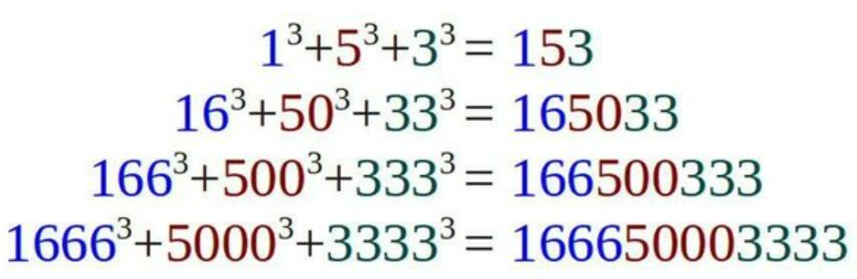

**The number pattern can continue, can you prove this using algebra?**

The proof is as follows:

${\left(\frac{{10}^{n}-4}{6}\right)}^{3}$**+ ${\left(\frac{{10}^{n}}{2}\right)}^{3}$ + ${\left(\frac{{10}^{n}-1}{3}\right)}^{3}$**

$=\frac{1}{6^{3}}\left[{\left({10}^{n}-4\right)}^{3}+27{\left({10}^{n}\right)}^{3}+8{\left({10}^{n}-1\right)}^{3}\right]$

$=\frac{1}{6^{3}}\left[\begin{aligned}\left({10}^{3n}-12×{10}^{2n}+48×{10}^{n}-64\right)+27×{10}^{3n} \\ +\left(8×{10}^{3n}-24×{10}^{2n}+24×{10}^{n}-8\right)\end{aligned}\right]$

$=\frac{1}{6^{3}}\left[36×{10}^{3n}-36×{10}^{2n}+72×{10}^{n}-72\right]$

$=\frac{1}{6}\left[{10}^{3n}-{10}^{2n}+2×{10}^{n}-2\right]$

$=$ $\frac{1}{6}\left({10}^{3n}-4×{10}^{2n}\right)$ $+5×{10}^{2n-1}$**+ $\frac{{10}^{n}-1}{3}$**

**29/6/2022**